University of Pittsburgh at Johnstown

Electrical and Computer Engineering Department SENIOR DESIGN COE1199

Cycle Statistic Tool

Weekly Memorandum
To: | Maddumage Karunaratne
From: | Jacob Hoffman  Cody Klingler

cc:
Date: | 04/05/2021

Re:

Achievements:

Cody: The final design for the display was completed as seen in Figure 1. More classes were implemented for the microcontrollers. The new code is written in a way that makes it easier to calculate rolling averages and update bluetooth characteristics. Overall, altering the microcontroller code should be much more manageable now. Some of the SPACE deliverables were finished this week, most importantly the poster.

Jacob: The bluetooth LE connectivity is almost complete. The application is now able to display a list of discoverable devices for the user to view. Additionally, the application is programmed to connect to the CST device and search for the CST Service. Once this service is connected, the application can get each characteristic from the service. In Figure 2, the list of characteristics discoverable under the CST Service is displayed. We are finishing up the application’s ability to handle each characteristic and dynamically display them to the user. Additionally, the layout for the Trip Page UI was programmed. This was not necessarily complicated, but took some time to finish up. The current UI design is shown in Figure 3. The project team also spent time setting up resources for the SPACE convention that will be held on 04/07/21.

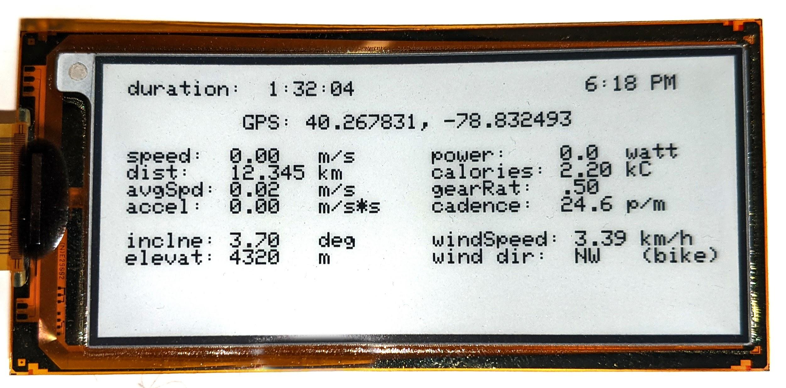
Figure 1: CST Display

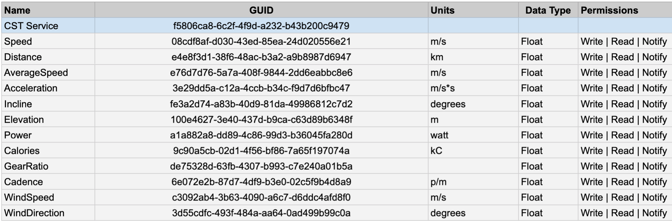
Figure 2: Updated GATT Attribute Table

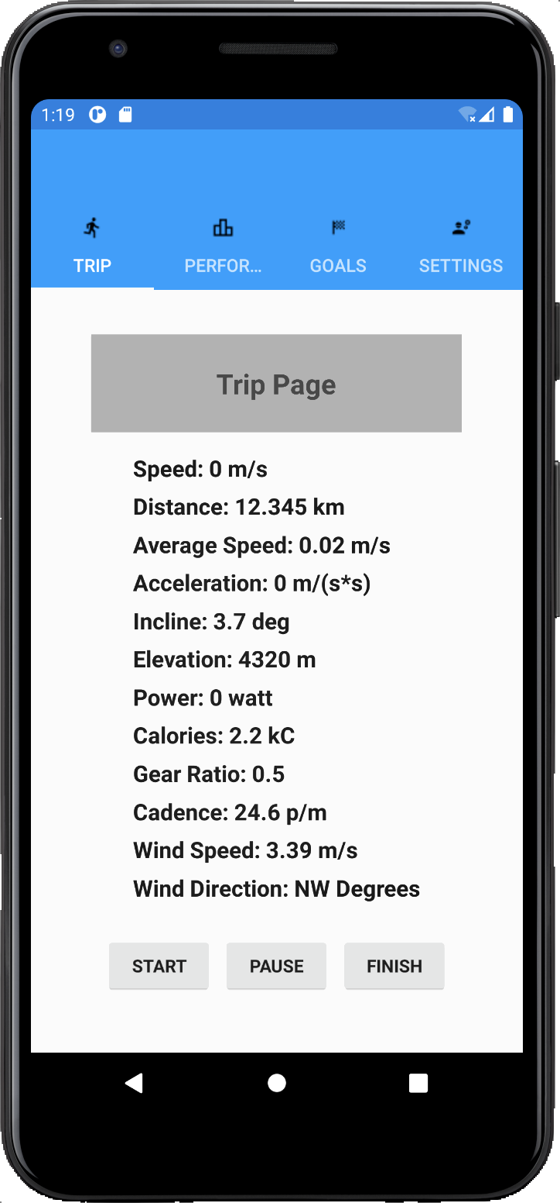
Figure 3: Trip Page UI Design

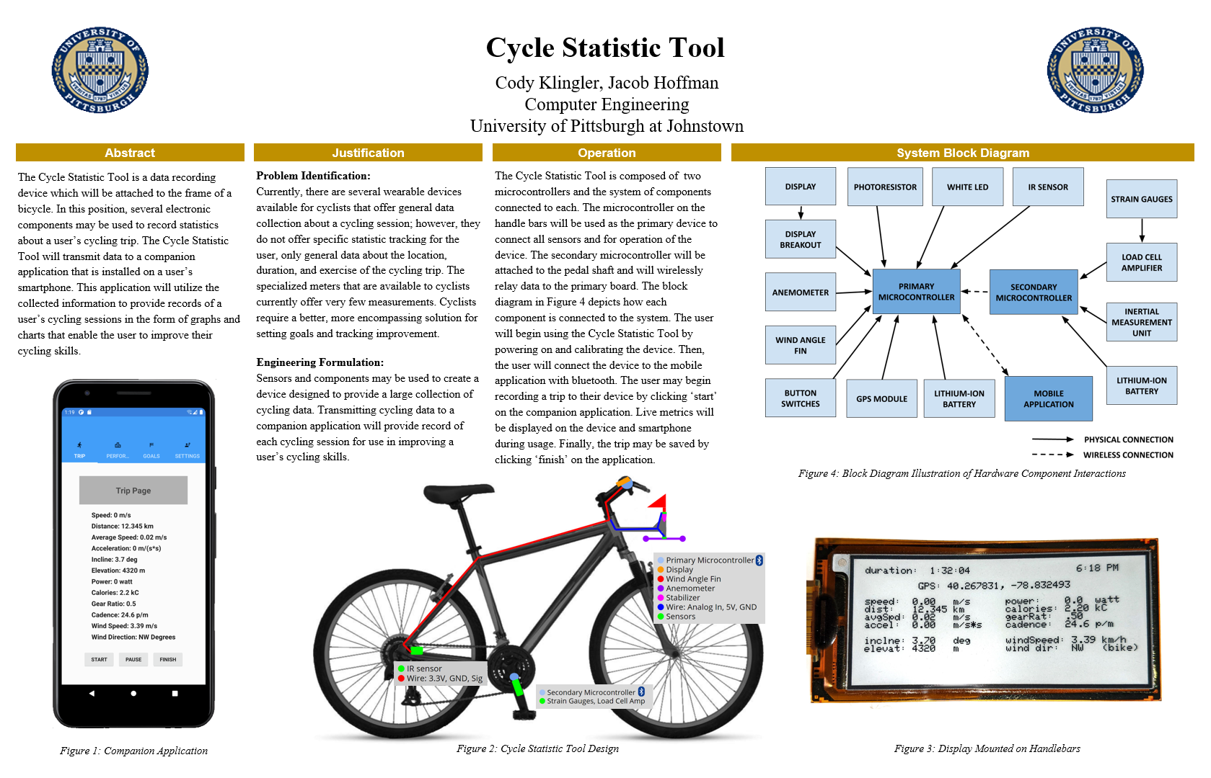
Figure 4: SPACE Poster

Issues Encountered and Solved:

Cody: While soldering hardware last week, a couple of the pins on one of the arduinos came out. To ensure that this would not become problematic, I ordered another microcontroller ($20). The new microcontroller was only able to be programmed twice before it stopped connecting to my computer. I resoldered the header onto the microcontroller with the missing pins, but I haven’t tested it yet.

Jacob: Earlier in the project, I had some issues with the icon and titles for each tab in the application not displaying. I fixed this issue. I did not have the title and icon correctly declared in two of the pages, so when they were labeled as children in the tabbed page (meaning they were used as a page to select in the tabbed page navigation bar), the title and icon were not appearing. Additionally, the issues with trying to launch a list of discoverable BLE devices was resolved. There are certain device permissions that the user must give to the application before bluetooth functionality is enabled. I did not prompt the user to enable these specific permissions.

Issues Encountered and Unresolved:

Cody: None.

Jacob: None.
Goals and Tasks For Next Week:

Cody: I’d like to finish the microcontroller code rework before SPACE and get a live demo featuring all of the most important statistics of the bike. After this, my goal will be to either solder the final hardware for the primary microcontroller or test BLE with Jake.

Jacob: The BLE connectivity is being finished up. Once it is in a state where it can build, we will begin testing bluetooth communications.

Project Schedule:

Cody: The GANTT’s hardware path is still on last week’s schedule.

Jacob: The mobile application should be in a state where we can begin testing bluetooth communications. We are still finishing up coding the mobile application, which is scheduled to be finished on 04/02/21. We are behind schedule with respect to the GANTT chart.

Project Logbook:

Cody:
4/2/2021 - 4.5 hours

Worked on SPACE deliverables, primarily poster and banner. Also designed the display, so that can be marked off of the GANTT. One of my arduinos stopped connecting to my computer during this time. the bootloader may have been corrupted.

4/3/2021 - 6.0 hours

Continued finalizing microcontroller code. Implemented event based classes to update individual components, which then make update calls to bluetooth characteristics. The way the code is being written allows the programmer to tare values and calculate rolling averages very easily. I may change my implementation to use lists if I can afford the memory. This would allow for more accurate averages to be shown when the display is refreshed. Soldered headers onto another microcontroller, since one of them wouldn't work.

Jacob:

03/29/21 - 6 hours

I stopped working with the merged application and went back to my previous code. I was able to get it working! I was missing some code that makes the user enable permissions. The application currently prompts the user with a list of discovered bluetooth devices.

04/02/21 - 8 hours

I started developing the trip page layout. I wanted to get the overall design finished and wire it up temporarily to a sample data recorded entry. This was finished and some of the bluetooth code was continued. Cody and I had to prepare all of our resources to turn in for SPACE. I began working on our poster earlier in the day and we both finished the poster at night.

04/04/21 - 6 hours

I am trying to finish wrapping up the bluetooth LE code so I can give an operating version to Cody and he can test it. We have also been preparing the project for a presentation during SPACE. Anyways, the application can now search for specific services and characteristics. I am setting everything up so that all characteristics being broadcasted by the CST are being observed and change the UI dynamically on the smartphone. Once this is finished, the bluetooth code is basically finished. Then, we can test recording trips and (assuming the trips can be saved successfully) the performance page can be set up. Finally, I made revisions to the GATT Attributes spreadsheet to reflect what Cody and I plan on transmitting across bluetooth.

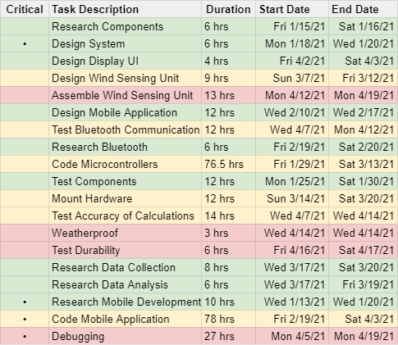
Task Division:
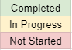
GANTT Chart:
